

Name: Khizar Ali Roll No: 22P-9269

Subject: Programing Fundamentals LAB

Submitted to: Muhammad Usman

Problem: 1

Write a program that will print the multiplication table( from 1 to 10) of user choice.

#include<stdio.h>

int main()

{

    int number,result;

    printf("Enter a Number for multiplication  table. \n");

    scanf("%d",&number);

    for(int i=1;i<=10;i++)

    {

        result=i*number;

        printf("%d * %d = %d \n",number,i,result);

    }

    return 0;

}

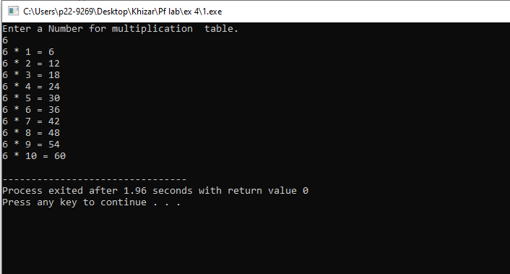

**Problem 2:**

**Write a program in c that counts the number of digits in an integer.**

#include<stdio.h>

int main()

{

    int  number;

    int count=0;

    printf("Enter a number \n");

    scanf("%d",&number);

    while(number != 0)

    {

        number=number/10;

        count=count+1;

    }

    printf("The digits of number are %d \n",count );

    return 0;

}

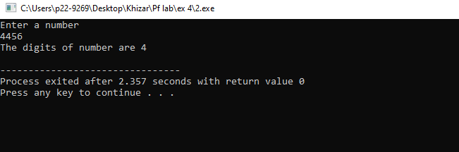

**Problem 3:** **Write a Program to Calculate Permutation(nPr) for given values of n and r**

#include<stdio.h>

int main()

{

    int  n,r , Nr,N1=1,N2=1 ;

    printf("Enter value of n  \n");

    scanf("%d",&n);

    printf("Enter value of r  \n");

    scanf("%d",&r);

    Nr=n-r;

    if (n>0)

    {

      for(int i=1;i<=n;++i)

      {

        N1=N1*i;

      }

        {

            for(int i=1;i<=Nr;i++)

            N2=N2*i;

        }

    int result =N1/N2;

    printf("npr for n=%d & r= %d = %d",n,r,result);

    }

    else

    {

       printf("The factorial on negitive number is not possilbe \n");

    }

    return 0;

}

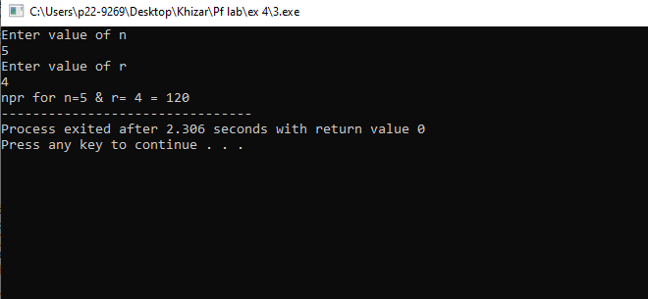

Problem 4: Modify a calculator you made in the last lab. This time your function ask user to

enter the number and the operation you want to perform (+,-,*,/) after the operation is performed your program should ask the user whether you want to continue (y/n)? your program will exit only when user enter “n”

#include<stdio.h>

int main()

{

    int sum, product, divide,subtract;

    int a , b ;

    char c, x;

do{

    printf("Enter the operation you want to perform (*,+,-,/) \n ");

    scanf("\n%c",&c);

    printf("Enter value of a \n ");

    scanf("%d",&a);

    printf("Enter value of b \n ");

    scanf("%d",&b);

    if(c=='+')

    {

        sum=a+b;

        printf("%d + %d = %d  \n", a , b , sum );

    }

else if(c=='-')

    {

        subtract=a-b;

        printf("%d - %d = %d  \n", a , b , subtract );

    }

else if(c=='*')

    {

        product=a*b;

        printf("%d * %d = %d  \n", a , b , product );

    }

else

    {

        divide=a/b;

        printf("%d / %d = %d  \n", a , b , divide  );

    }

    printf("press y if you want to continue esle n \n");

    scanf("\n%c",&x);

}

while(x=='y');

return 0;

}

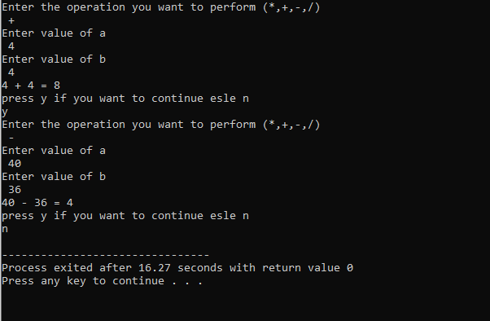

Problem 5:

Find the sum of the first 10 numbers that are divisible by 3 and 5.

#include<stdio.h>

int main()

{

int sum=0;

int counter=10;

int N1,N2;

for(int i=1;counter!=0;i++)

{

     N1=i%3;

     N2=i%5;

    if(N1==0 && N2==0)

    {

     sum=sum+i;

     counter=counter-1;

    }

}

printf("The sum of 10 numbers which are divisible by 3 and 5 is %d.\n",sum);

return 0;

}

